上海海事大学

“软件项目管理”技术报告



题目：**Real-time AI Fitness Monitoring System**

**作者姓名 王昊，王绪龙，裘罗荧 （第七组）**

**指导教师 刘晋**

**所在学院 信息工程学院**

**提交日期 二零二三年六月**

## 1.Background

At present, people's demand for sports and fitness is increasing, and the application trend of health sports combined with high technology, online and big data is obvious. According to the Research report on China's Sports and Fitness Market in the third quarter of 2020, under the influence of the epidemic, residents' fitness and health issues have become a national social topic. So we decided to build a motion counting system to monitor our exercise.

## 2.Project introduction

This project aims to use the Mediapipe framework to build a human body posture detection model to achieve counting of push-ups and squats, and import the trained model into a mobile application to achieve real-time counting by calling the camera. This program can help users better grasp their own exercise status and improve exercise effects.

Function：Our system is a real-time fitness counting system, which can automatically tally user data or verify the quality of exercise performed and make real-time counts. Our system can count some exercises that do not require equipment, such as Push-up. The count can be done in real time by holding a phone in front of a portrait, making sure the whole body is visible and unshaded.

## 3.Technical Support

There is an application branch of computer vision called Human Pose Estimation, which can estimate one or more people's attitude information in a key way，there are usually 17 key points. As shown in the picture on the right:

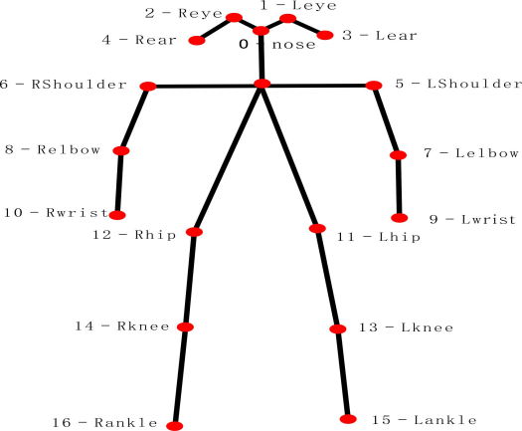

Technology Introduction：

Mediapipe is an open source project from google that provides open source, cross-platform common machine learning solutions. Mediapipe is actually an integrated tool library of machine learning visual algorithms, including face detection, face key, gesture recognition, avatar segmentation, and pose recognition models.

K-NearestNeighbor as one of the simplest classification methods in data mining, it is widely used in classification, regression, pattern recognition and so on.

## 4.Dataset

Loading the dataset, the image should repeat the terminal state of the desired pose class.To classify push-ups, you need to provide dimensions for two categories: when the person is up and when the person is down.Each class should have about dozens or hundreds of samples, covering different camera angles, environmental conditions, body shape and motion variations, to build a good classifier.

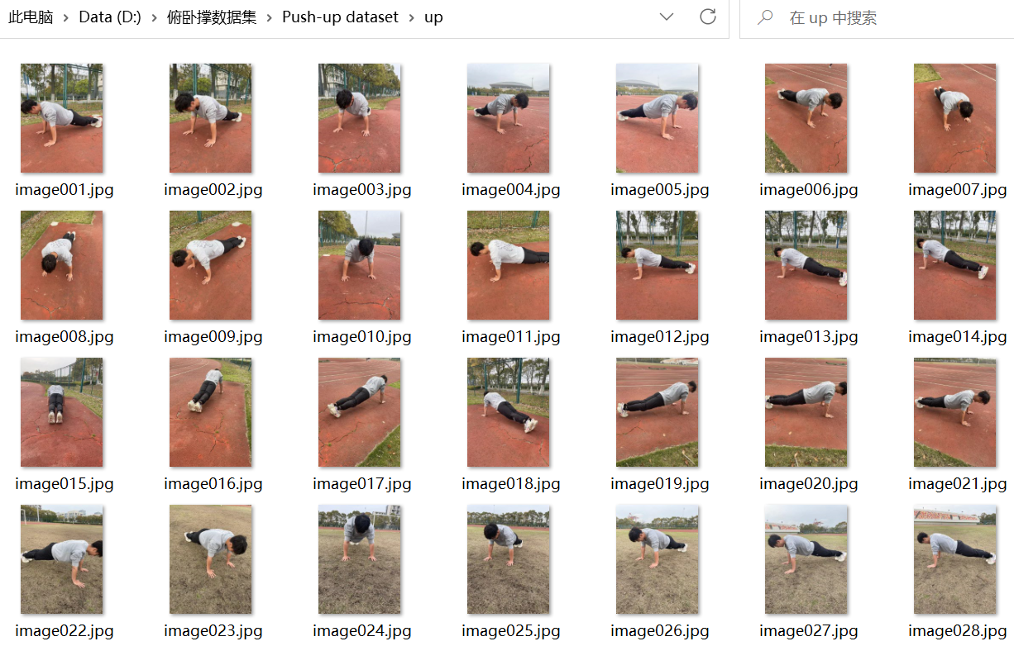

## 5.Project Schedule

This is the project schedule, and the penultimate column is the actual completion time of the project activities. There are varying degrees of delays in the mid-project code writing and testing phases.

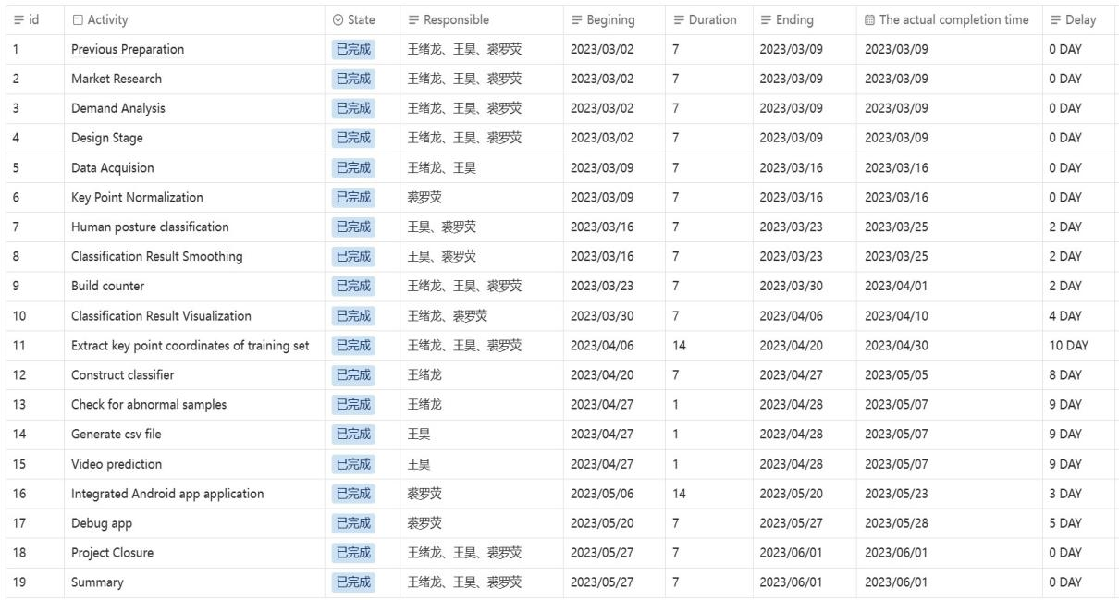

This is a graph of the planned time and actual completion time of each phase of the project. The green curve represents the project's planned time, and the orange curve represents the actual completion time of the project. Compared with the plan, there were different degrees of delays in each stage, but the project was finally completed before the stipulated time.

## 6. Project Design

The specific plan is as follows:

(1) Collect image samples for target exercises and perform pose prediction on them.

(2) Convert the obtained pose flags into data suitable for a K-NN classifier, and use these data to form a training set.

(3) Perform the classification itself, followed by repeated counting.

(4) Use machine learning kits to detect gestures in Android development.

(5) Build app-related instances.

(6) Add the CSV file to the app's assets folder.

(7) Run the application, export the .apk to the mobile terminal for installation and use.

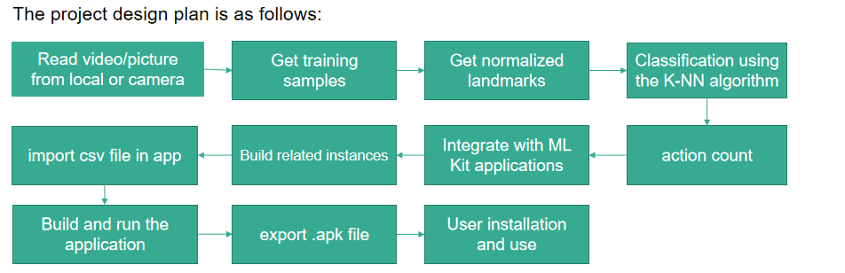

## 7.Project Process

We will divide the entire report into five stages

Stage 1(3-4weeks)：The push up dataset contains at least 50 images, including at least 25 training images for the down and up movements.

The squat dataset should contain at least 50 images, with at least 25 training images for the squat down and up actions, respectively.

Stage 2(5-8weeks) ：We need to ensure that the FPS of the trained model exceeds 10, so that the project does not get stuck during work (FPS=10 means processing ten images per second)

Stage 3(9-11weeks)：We need to test the basic functions of the entire project, such as key point detection of a single human body and real-time scheduling of cameras

Stage 4：(12-13weeks)We need to test our model in different environments,（For example, on the playground, in the dormitory, in the indoor sports field）select at least five scenarios, and count accurately,We need to complete this work within a week

Stage 5(14-15)：Deploy our project to the front-end app and ensure it can be used normally

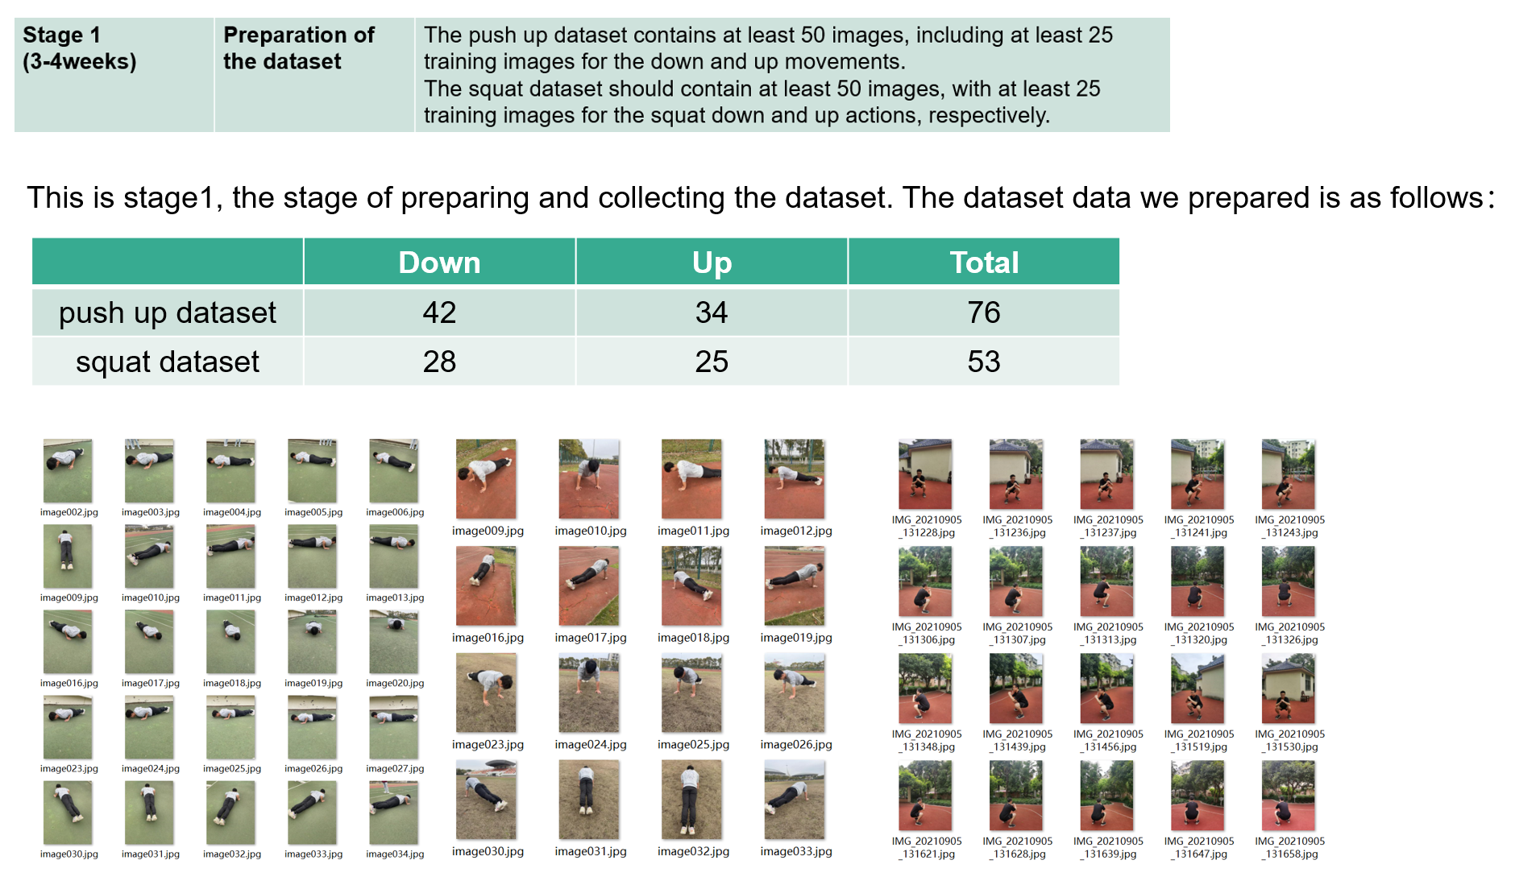

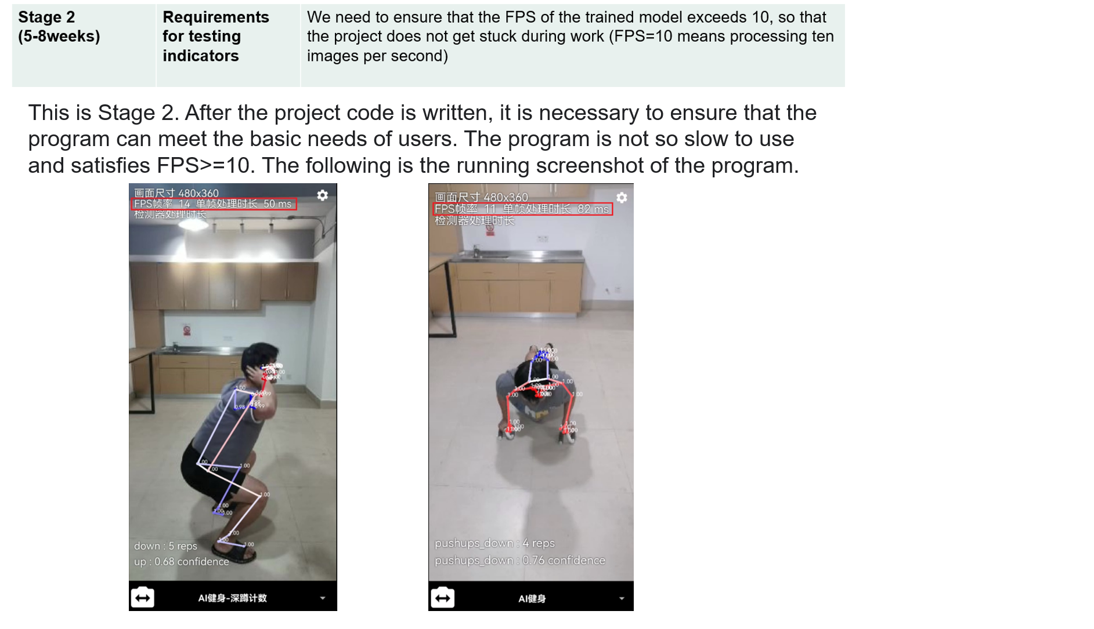

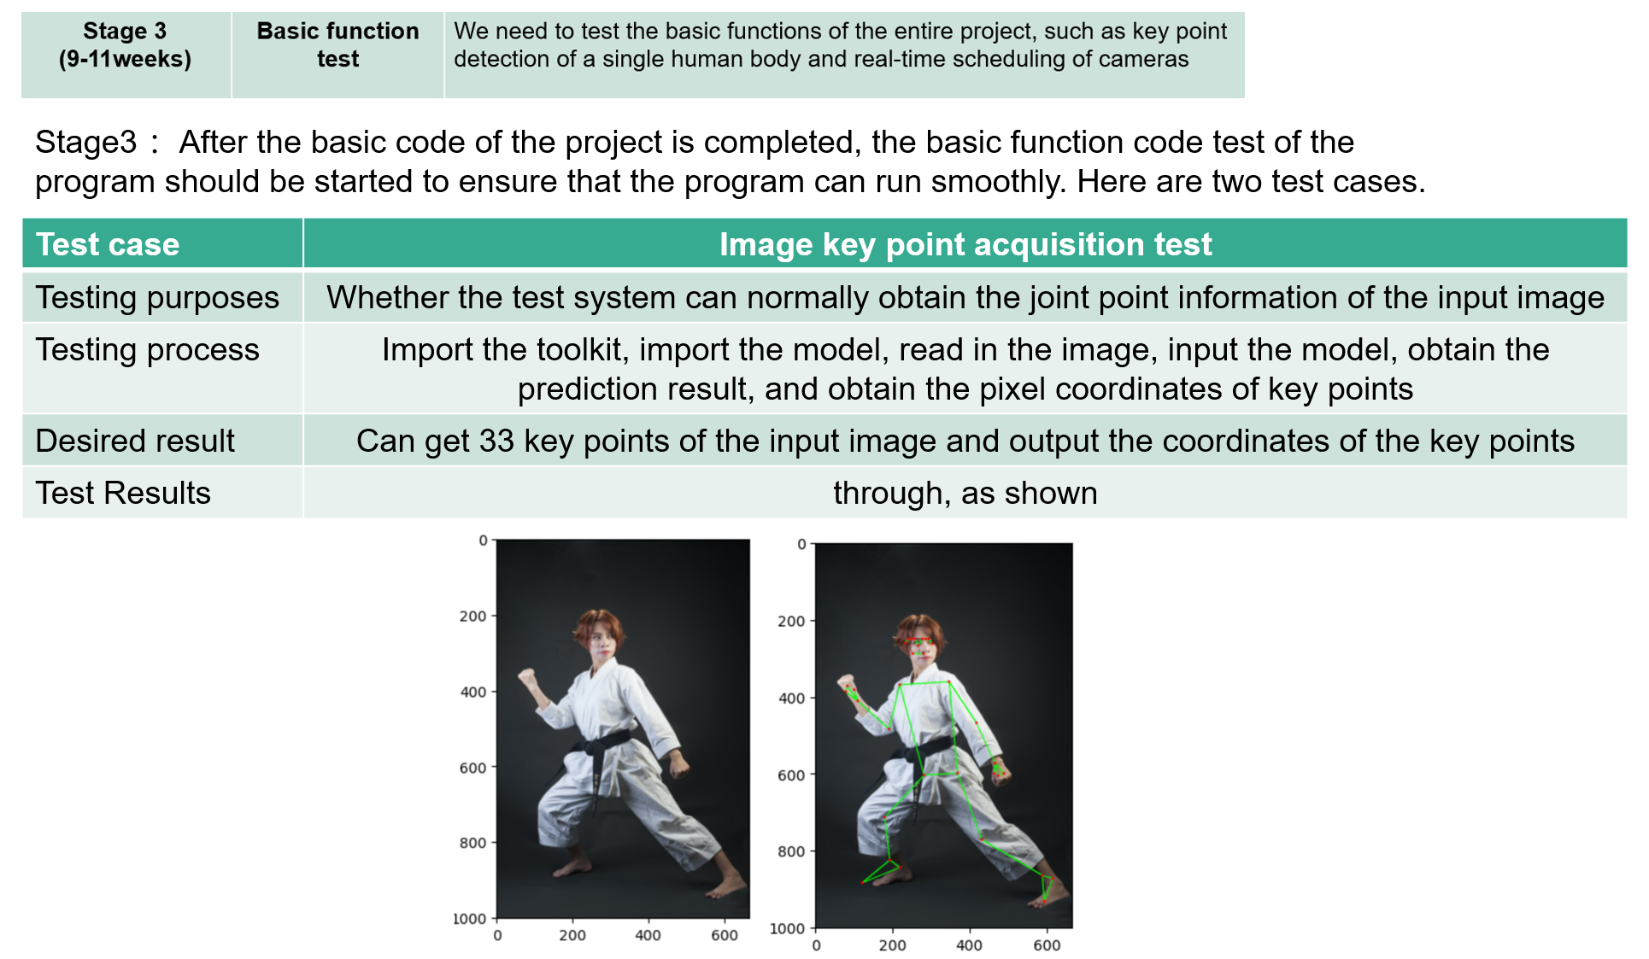

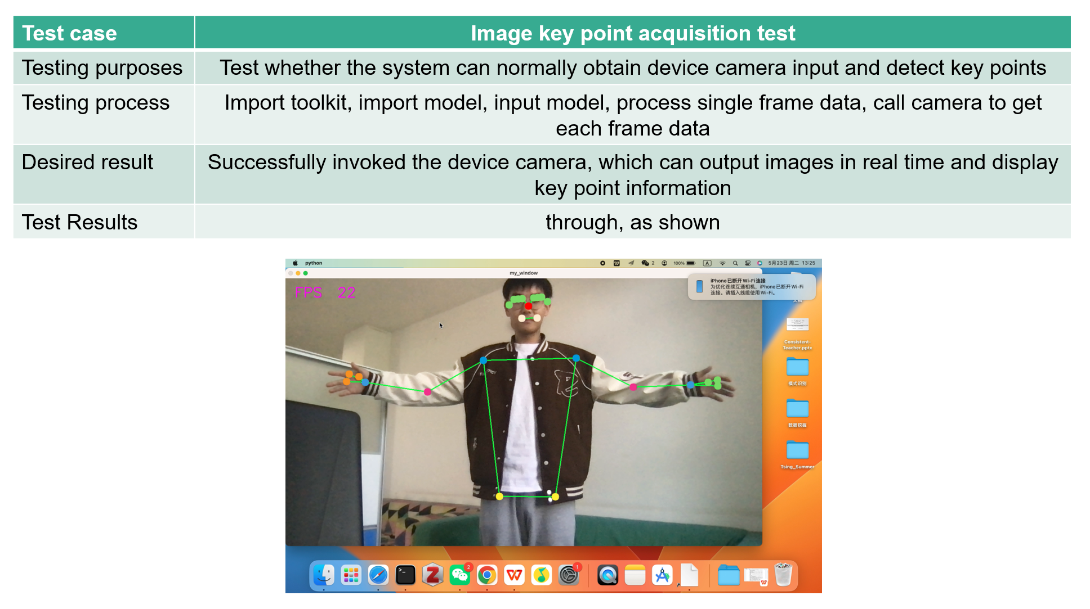

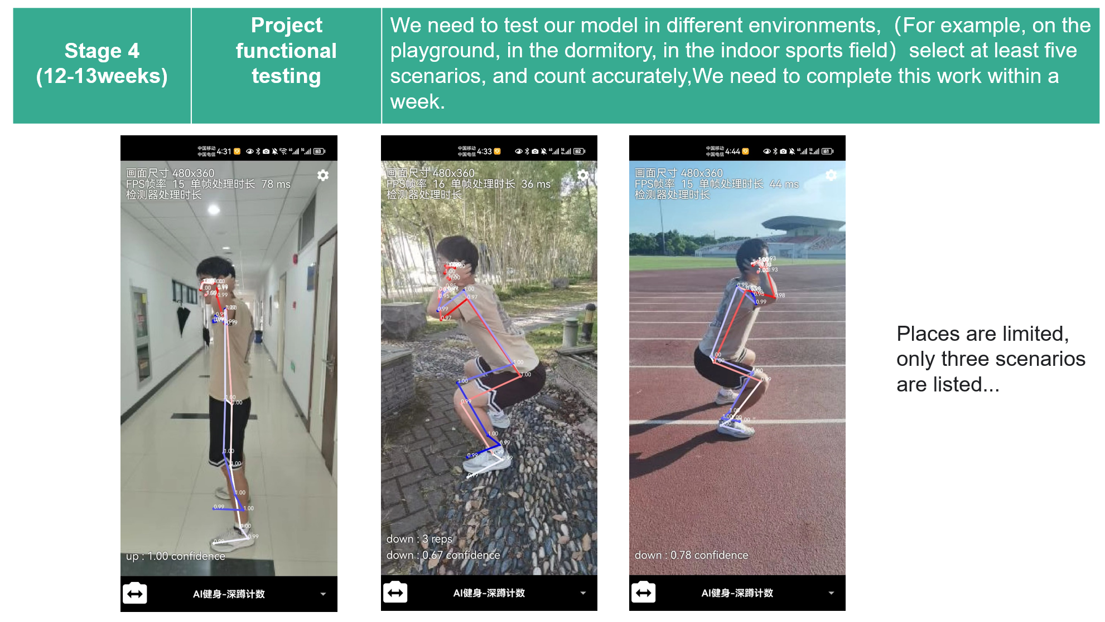

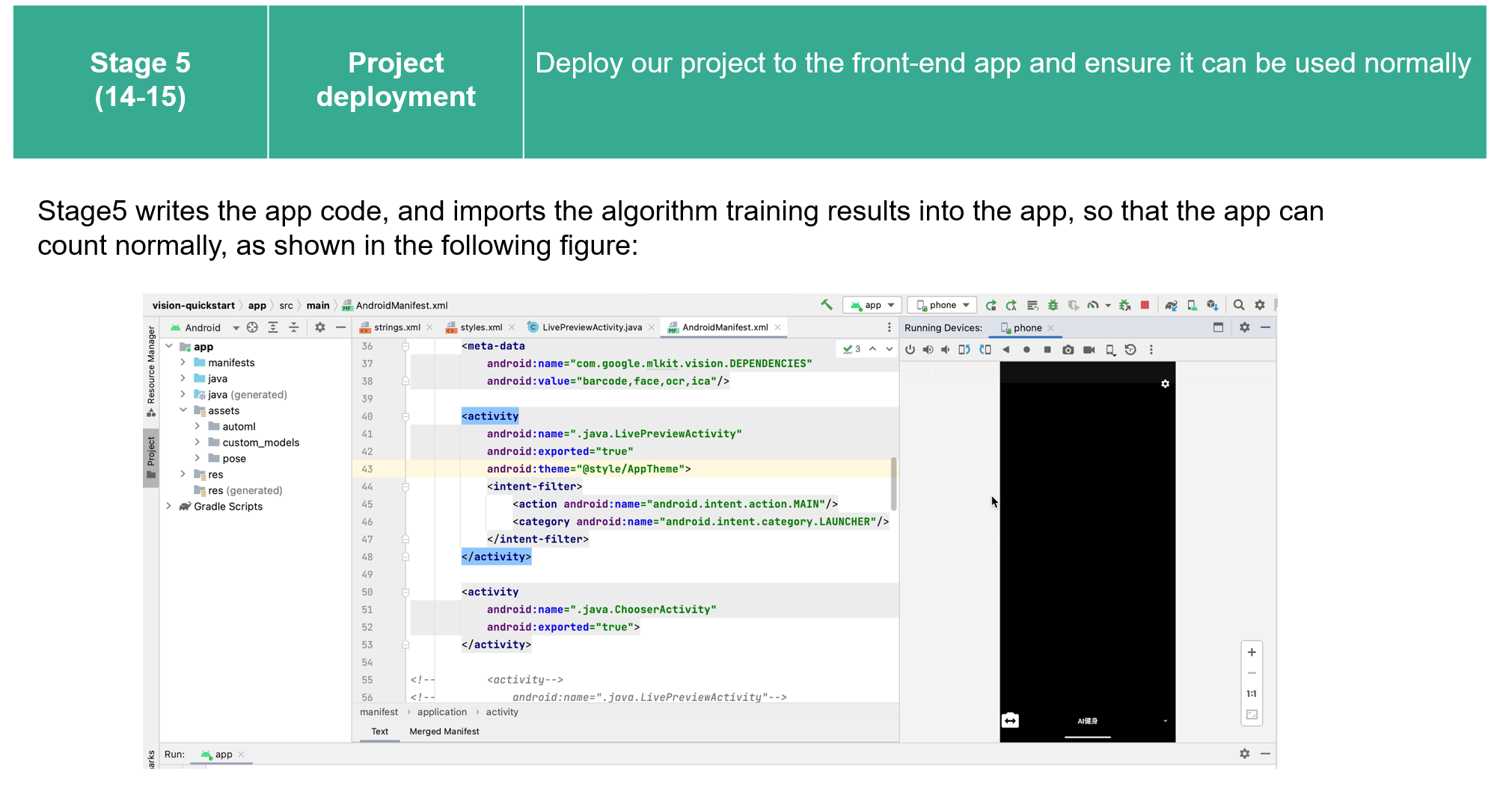

## 8.Project Risk

At present, people's demand for sports and fitness is increasing, and the application trend of health sports combined with high technology, online and big data is obvious.According to the Research report on China's Sports and Fitness Market in the third quarter of 2020, under the influence of the epidemic, residents' fitness and health issues have become a national social topic.So we decided to build a motion counting system to monitor our exercise.During the project development process, there may be some risks that require risk management and control.When it comes to projects or businesses, risks are unavoidable.Risk management is a systematic approach that can help identify, evaluate, and mitigate these risks to ensure the success of a project or business.Risk planning is a part of risk management that describes how to identify, evaluate, mitigate, and monitor risks in a project or business.Risk planning is an important tool that can help management teams predict potential problems and take measures to mitigate the impact of risks.

|  |  |  |  |  |  |
| --- | --- | --- | --- | --- | --- |
| classification | risk | r isk description | risk grade | Risk probability | Risk impact |
|  | The algorithm is inaccurate | The accuracy of the algorithm depends on the quality and quantity of the dataset, and it may be affected if the training dataset is either insufficient or less accurate. | Medium | 10%-30% | 0.6 |
|  | code error | If the code has an error, it may cause the program to crash or produce an incorrect output. | High | 20%-40% | 0.8 |
|  | Compatibility problem | The program may be incompatible with some hardware or software. | Medium | 15%-30% | 0.6 |
| Technical risk | security hole | If the program involves user data or sensitive information, security vulnerabilities may exist. | High | 10%-20% | 0.9 |
|  | Performance problems | Performance problems may arise when a program needs to process large amounts of data or perform complex calculations. | Medium | 10%-20% | 0.7 |
|  | Program scalability issues | If the program requires to extend or modify, scalability issues may arise. | High | 10%-20% | 0.6 |
|  | Data quality issues | If the program needs to process large amounts of data, data quality issues may arise. | Medium | 20%-30% | 0.7 |
|  | Program dependency issues | If a program depends on other software or libraries, dependency problems may arise. | Medium | 10%-30% | 0.5 |
|  | Quality risk | Users have high requirements for software quality, and if the project team members lack the development experience of the same type of projects, they need to pay close attention to the quality risk of the project. | Medium | 10%-15% | 0.6 |
|  | Data leakage | If the program involves user data or sensitive information, there may be a risk of data leakage. | High | 5%-20% | 0.8 |
| security risk | network attack | If the program communicates through the network, there may be a risk of a network attack. | High | Depends on the details of the project and the improvement of the safety measures | 0.9 |
|  | malicious software | If the program has a vulnerability or a security vulnerability, it may be attacked by malicious software. | Medium | Depends on the details of the project and the improvement of the safety measures | 0.6 |
|  | Code injection | If the program has a security vulnerability, it may be attacked by the code injection. | Medium | Depends on the details of the project and the improvement of the safety measures | 0.6 |
|  | privacy leak | If the program collects the user's personal health data, such as height, weight, heart rate, etc., then the data may be hacked or used improperly. | High | Depends on the details of the project and the improvement of the safety measures | 0.8 |
|  | data security | If the data is not properly stored or secure, then hackers may easily obtain the data, leading to personal privacy leakage of users. | High | Depends on the details of the project and the improvement of the safety measures | 0.9 |
| Legal and ethical risks | Liability and exemption clause | If the program fails to properly count the number of squats and push-ups, then the user may be harmed. In this case, the developer of the program may face legal action. | centre | 5% | 0.6 |
|  | ethical principle | Developers should follow ethical principles to ensure that their programs do not harm users or violate their personal privacy. | low | 5% | 0.3 |
|  | Abide by laws and regulations | Developers should comply with local laws and regulations to ensure that their procedures do not violate any laws and regulations. | low | 5% | 0.2 |
| Manage risk | Demand change risk | In the development process, there may be unclear definition of requirements, insufficient accuracy, or users do not really understand their needs, as well as various problems and technical support in the APP development process, which may cause the risk of demand change. | Medium | It ends on many factors, such as the size of the project, complexity, the effectiveness of demand management, the change of customer needs and so on. | 0.6 |
| Personnel risk | Poor risk of communication | Poor communication among members of the project is a very important factor affecting the smooth progress of the project. There may be differences in needs, development direction and technology leading to poor communication. | High | It depends on multiple factors, such as the background and cultural differences of the team members, the choice of communication methods and tools, the clarity and accuracy of the communication content, etc | 0.8 |
| Progress risk | Schedule delay | The project is demanding on the schedule, and the project schedule delay means the failed development. | High | 5%-10% | 0.8 |

**Risk Mitigation,Monitoring,Management**

|  |  |  |  |
| --- | --- | --- | --- |
| Risk | Risk Mitigation | Risk Monitoring | Risk Management |
| The algorithm is inaccurate | Ensure the correctness of the algorithm, including theoretical proof, testing, etc.;  Optimize the algorithm to improve its accuracy and robustness;  Introduce the manual intervention mechanism to review and correct the algorithm results; | Monitor the output results of the algorithm, and find and correct the errors in time;  Monitor the operation of the algorithm, discover and solve the performance problems;  Monitor the use of the algorithm, collect user feedback and suggestions, and make timely improvement. | Establish a perfect algorithm development process, including demand analysis, design, development, testing, release and other links, to ensure the quality and stability of the algorithm |
| code error | Write high-quality code, follow best practices and standard specifications, and ensure code quality and readability.  Use automated test tools, such as unit testing, integration testing, and end-to-end testing, to ensure code correctness and stability. | Regular code review and testing to detect and fix potential errors. | Establish a management process for code errors and vulnerabilities to ensure timely detection and repair.  Establish a disaster recovery plan to respond to system failures and data loss caused by code errors. |
| Compatibility problem | During the design and development stages, consider compatibility issues across platforms and across browsers, ensuring that the code can be run in different environments. | Conduct compatibility tests to ensure that the application works properly in different environments. | Establish the management process of compatibility issues, and find and fix the problems in time. |
| security hole | Using security coding practices, such as input validation, error handling, and security configuration, can help reduce vulnerabilities in the code. | Scan for security vulnerabilities regularly, and take timely measures | Establish a security vulnerability management process to ensure the timely detection and repair of vulnerabilities. |
| Performance problems | During development, performance tests should be performed periodically to ensure that the system can meet the desired performance requirements. | Monitor the system performance, timely identify the performance problems and bottlenecks, and take measures in time | Establish performance problem management processes to ensure timely detection and resolution of performance issues. |
| Program scalability issues | A modular design and development approach enables individual parts of the system to be developed, tested, and deployed independently | Track the expansion requirements and changes of the system, and modify and optimize accordingly in time. | Establish scalability planning and strategies, including the system architecture, design, and development process, to ensure that the system can meet the future expansion requirements. |
| Data quality issues | Clean the data to remove duplicate, invalid or incorrect data to ensure the accuracy and completeness of the data. | Monitor data quality regularly, for example, through data quality reports or data monitoring tools, to timely detect data quality problems and take corresponding measures | Develop a data management plan, including data collection, data processing, data storage and other processes, clarify the responsibility and process of data management, and ensure the quality and safety of data |
| Program dependency issues | Management program dependency, including dependent version, dependent source, dependent update, etc., to ensure the reliability and stability of dependency. | Monitor dependent versions regularly, detect changes in dependent versions and take appropriate measures, such as upgrading or fallback dependent versions. | Develop a dependency management plan, including the choice of dependence, the management of dependence, dependency update, etc., to ensure the reliability and stability of dependence. |
| Quality risk | Develop detailed test plans and test cases to ensure the quality of the software | Establish a quality control mechanism to monitor and manage the quality in the software development process | Establish a quality management plan, define the quality objectives and quality standards, and formulate the corresponding quality control measures and quality assurance measures. |
| Data leakage | Encrypted storage and transmission of sensitive data to ensure the security of the data.  Establish an access control mechanism to limit and control the access to the data. | Establish a data monitoring mechanism to monitor and record the access and use of data. | Establish a data security management plan, clarify the data security goals and standards, and formulate the corresponding data security control measures and data security safeguard measures. |
| network attack | Conduct regular vulnerability scanning and security assessment of the system, timely repair of vulnerabilities and strengthen security measures. | Conduct regular safety audit and safety assessment to find and solve safety problems in time | Formulate emergency plans and vulnerability repair plans to ensure that they can be timely addressed and solved when security problems occur. |
| malicious software | Install anti-virus software, firewall and other security software, timely upgrade and update, to ensure that it can timely detect and clear malicious software. | Regular anti-virus scanning and security inspection of the system, timely detect and remove malicious software. | Develop contingency plans and malware removal plans to ensure that security issues can be addressed in time. |
| Code injection | Use secure programming languages and frameworks to avoid using known vulnerabilities and insecure functions.  When writing code, avoid the way of dynamic code execution, such as eval () function | Monitor system logs and abnormal events, and find and handle abnormal requests and operations in time. | Regular security vulnerability scanning and security test on the system to find and fix vulnerabilities in time. |
| privacy leak | Take access control measures to limit access to sensitive information and ensure that only authorized persons have access. | Monitor system logs and abnormal events, and find and handle abnormal requests and operations in time. | Formulate privacy protection policies and privacy protection measures to ensure the security and confidentiality of sensitive personal information. |
| data security | Take data backup, access control, etc | Establish a monitoring mechanism to monitor the data storage, transmission and processing processes, and find and handle abnormal situations in time. | Establish a risk management mechanism for the comprehensive management and control of data security risks |
| Liability and exemption clause | Establish clear responsibilities and liability clauses to clarify the rights and obligations between developers and users | Establish a monitoring mechanism, monitor the developed products, timely find out the problems reported by users, and timely deal with and solve them. | Establish a risk management mechanism, and conduct a comprehensive management and control of the products |
| Demand change risk | Establish a clear demand change management mechanism, including the process of demand change, change application review and approval mechanism, etc., to ensure the rationality and feasibility of the demand change | Establish a demand change tracking mechanism, find and handle the demand change in time, and avoid the problems such as project delay caused by the demand change | Establish a risk management mechanism for the comprehensive management and control of demand changes |
| Poor risk of communication | Establish clear communication channels: ensure that team members can communicate and communicate smoothly, and establish a transparent, open and positive communication atmosphere.  Develop a clear communication plan: clarify the communication style, content and frequency of each stage, to ensure that everyone understands the communication plan, and can communicate according to the plan. | Evaluation the communication effect regularly, understand whether the communication achieves the expected effect, and timely find and correct the problems of bad communication. | Develop management plans for poor communication risks to ensure that poor communication risks are addressed in a timely and effective manner. |
| Schedule delay | Make a detailed project plan, including work content, workload, work time, work order, to ensure that everyone understands the project plan and can work according to the plan. | Monitor the progress implementation: to monitor and track the project progress regularly, find the progress deviation and problems in time, and take measures to adjust and correct them in time. | Develop a progress delay risk management plan to ensure the timely and effective response to the risk of progress delay. |

## 9.Project Test

At present, people's demand for sports and fitness is increasing, and the application trend of health sports combined with high technology, online and big data is obvious. According to the Research report on China's Sports and Fitness Market in the third quarter of 2020, under the influence of the epidemic, residents' fitness and health issues have become a national social topic.So we decided to build a motion counting system to monitor our exercise.

This is Test environment:

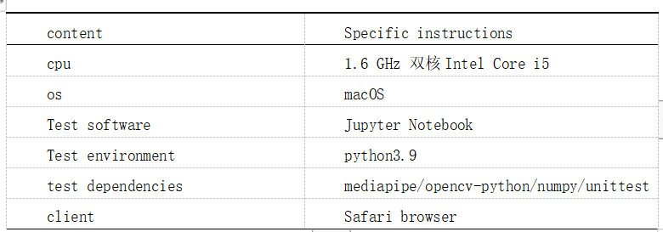

|  |
| --- |
| Test case 1: |
| Image key point acquisition test |
| Testing purposes: |
| Whether the test system can normally obtain the joint point information of the input image |
| Test Conditions: |
| The environment required for installation and testing: opencv-python, mediapipe, tqdm, time, matplotlib, unittest |
| Testing process:  Import the toolkit, import the model, read in the image, input the model, obtain the prediction result, and obtain the pixel coordinates of key points |
| Desired result:  Can get 33 key points of the input image and output the coordinates of the key points |
| Test Results:  fail |
| Reason for failure:  The image format read by opencv is BGR, and the visualization format of matplotlib is RGB, so you need to convert BGR to RGB |
| Test date: May 23, 2023 Testers：summer |

Test script:：

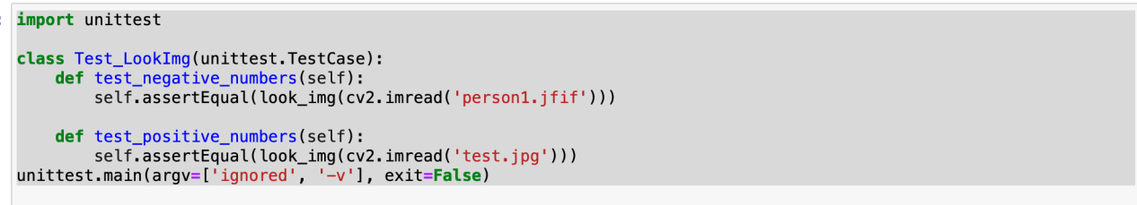

test_negative_numbers (__main__.Test_Pose) ... Fail

test_positive_numbers (__main__.Test_Pose) ... OK

=================================================================

ERROR: test_negative_numbers (__main__.Test_LookImg)

----------------------------------------------------------------------

Traceback (most recent call last):

File"/var/folders/rg/y2cj7c0d381gv6x04106261r0000gn/T/ipykernel_30525/3102635351.py", line 5, in test_negative_numbers

self.assertEqual(look_img(cv2.imread('person1.jfif')))

TypeError: assertEqual() missing 1 required positional argument: 'second'

----------------------------------------------------------------------

Ran 4 tests in 1.697s

modified script：

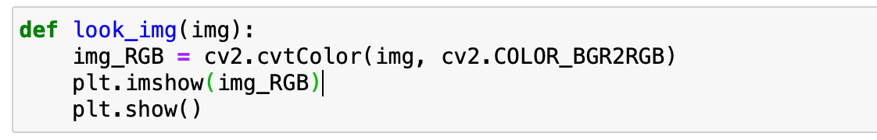

|  |
| --- |
| Test case 2:  Image key point acquisition test |
| Testing purposes:  Whether the test system can normally obtain the joint point information of the input image |
| Test Conditions:  The environment required for installation and testing: opencv-python, mediapipe, tqdm, time, matplotlib, unittest |
| Testing process:  Import the toolkit, import the model, read in the image, input the model, obtain the prediction result, and obtain the pixel coordinates of key points |
| Desired result:  Can get 33 key points of the input image and output the coordinates of the key points |
| Test result: failed |
| Reason for failure:  Different versions of mediapipe require different parameters for importing solution |
| Test date: May 23, 2023  Testers：summer |

test script：

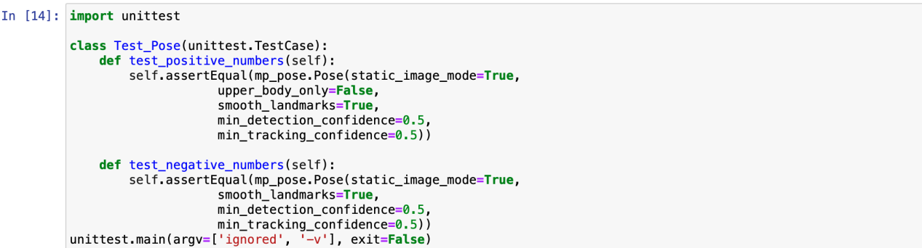

test_negative_numbers (__main__.Test_Pose) ... ERROR

test_positive_numbers (__main__.Test_Pose) ... OK

=================================================================

ERROR: test_negative_numbers (__main__.Test_LookImg)

----------------------------------------------------------------------

Traceback (most recent call last):

File"/var/folders/rg/y2cj7c0d381gv6x04106261r0000gn/T/ipykernel_30525/3102635351.py", line 5, in test_negative_numbers

self.assertEqual(mp_pose.Pose(static_image_mode=True,

upper_body_only=False,

smooth_landmarks=True,

min_detection_confidence=0.5,

min_tracking_confidence=0.5))

TypeError:Pose.__init__() got an unexpected keyword argument 'upper_body_only’

----------------------------------------------------------------------

Ran 1 tests in 2.527s

modified script：

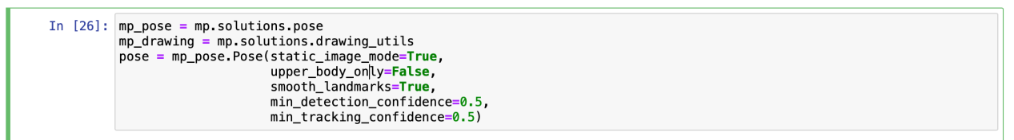

|  |
| --- |
| Test case 3:  Image key point acquisition test |
| Testing purposes:  Whether the test system can normally obtain the joint point information of the input image |
| Test Conditions:  The environment required for installation and testing: opencv-python, mediapipe, tqdm, time, matplotlib, unittest |
| Testing process:  Import the toolkit, import the model, read in the image, input the model, obtain the prediction result, and obtain the pixel coordinates of key points |
| Desired result:  Can get 33 key points of the input image and output the coordinates of the key points |
| Test result: passed, as shown in the figure |
| Test date: May 23, 2023 Tester: summer |

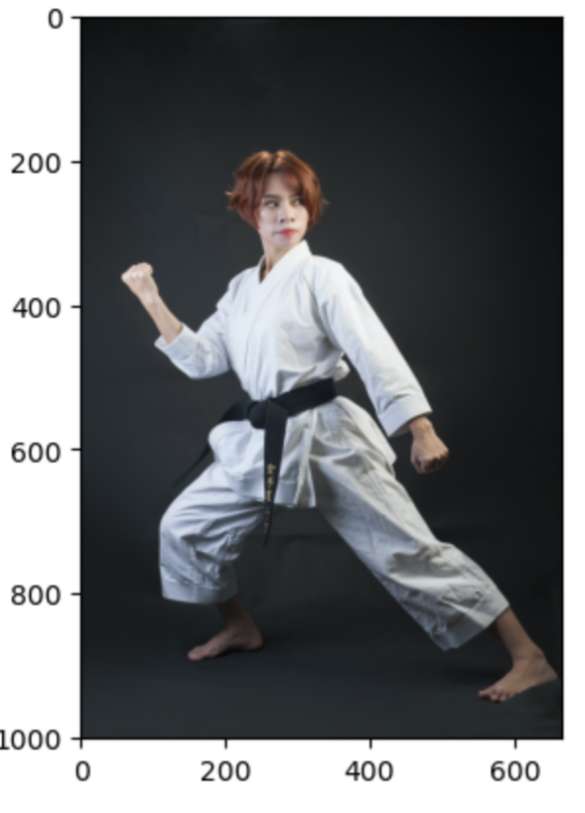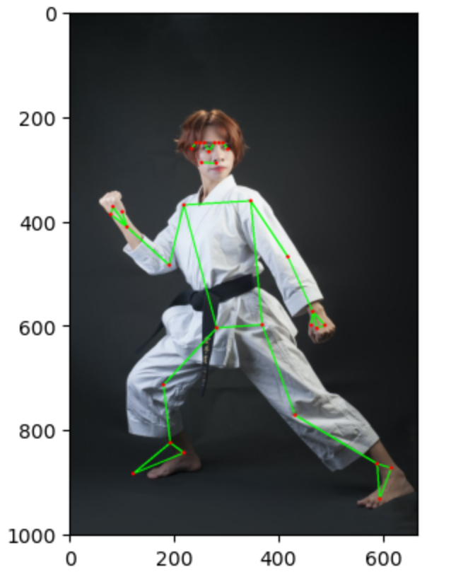

The key point coordinate information is shown in the figure：

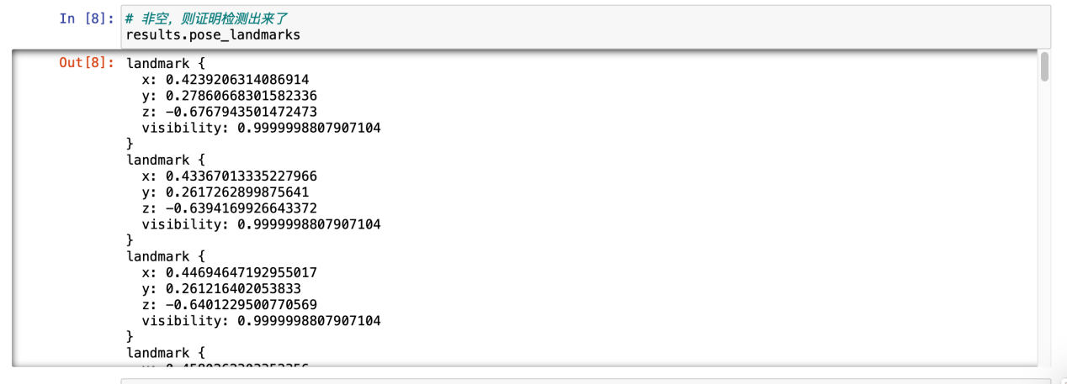

Test script：

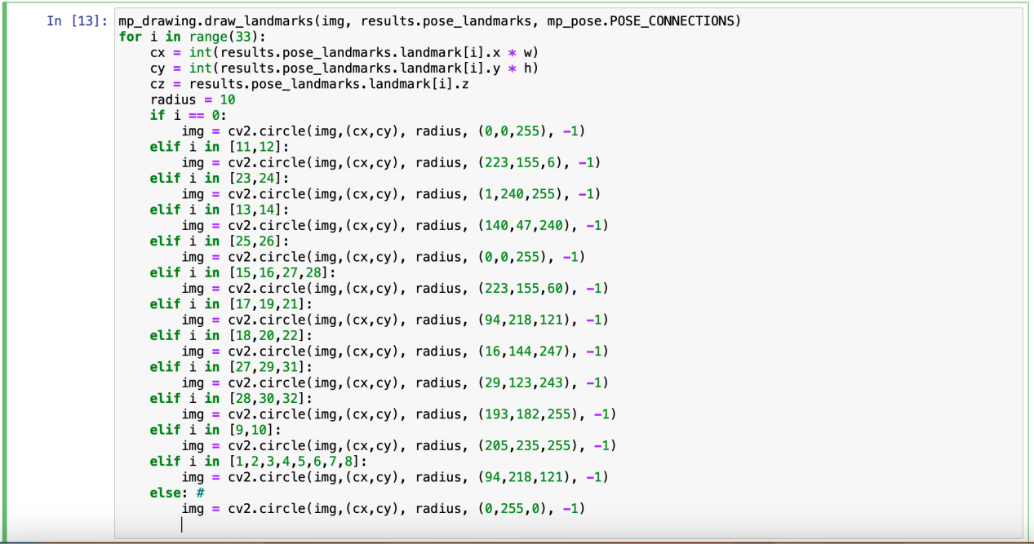

.

----------------------------------------------------------------------

Ran 1 test in 0.000s

OK

|  |
| --- |
| Test case 4:  Video Processing Test |
| Testing purposes:  Test whether the system can normally obtain the joint point information of the input video |
| Test Conditions:  The environment required for installation and testing: opencv-python, mediapipe, tqdm, time, unittest |
| Testing process:  Import toolkit, import model, input model, process single frame data, input video, process video frame by frame |
| Desired result:  Ability to output video with keypoint annotations |
| Test result: failed |
| Reason for failure:  There is a problem with the parameters passed in, and the video file cannot be obtained |
| Test date: May 23, 2023 Tester: summer |

Test script:

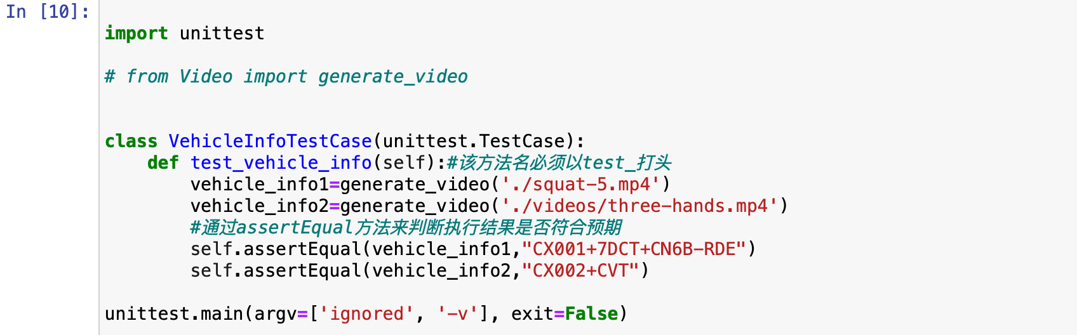

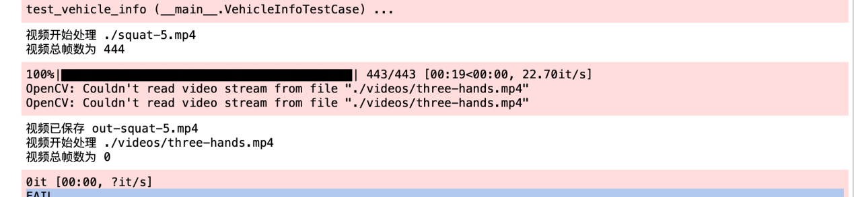

FAIL

=================================================================

FAIL: test_vehicle_info (__main__.VehicleInfoTestCase)

----------------------------------------------------------------------

Traceback (most recent call last):

File "/var/folders/rg/y2cj7c0d381gv6x04106261r0000gn/T/ipykernel_30830/2967315508.py", line 11, in test_vehicle_info

self.assertEqual(vehicle_info1,"CX001+7DCT+CN6B-RDE")

AssertionError: None != 'CX001+7DCT+CN6B-RDE'

----------------------------------------------------------------------

Ran 1 test in 23.110s

FAILED (failures=1)

|  |
| --- |
| Test case 5:  Video Processing Test |
| Testing purposes:  Test whether the system can normally obtain the joint point information of the input video |
| Test Conditions:  The environment required for installation and testing: opencv-python, mediapipe, tqdm, time, unittest |
| Testing process:  Import toolkit, import model, input model, process single frame data, input video, process video frame by frame |
| Desired result:  Ability to output video with keypoint annotations |
| Test result:  passed, as shown in the figure |



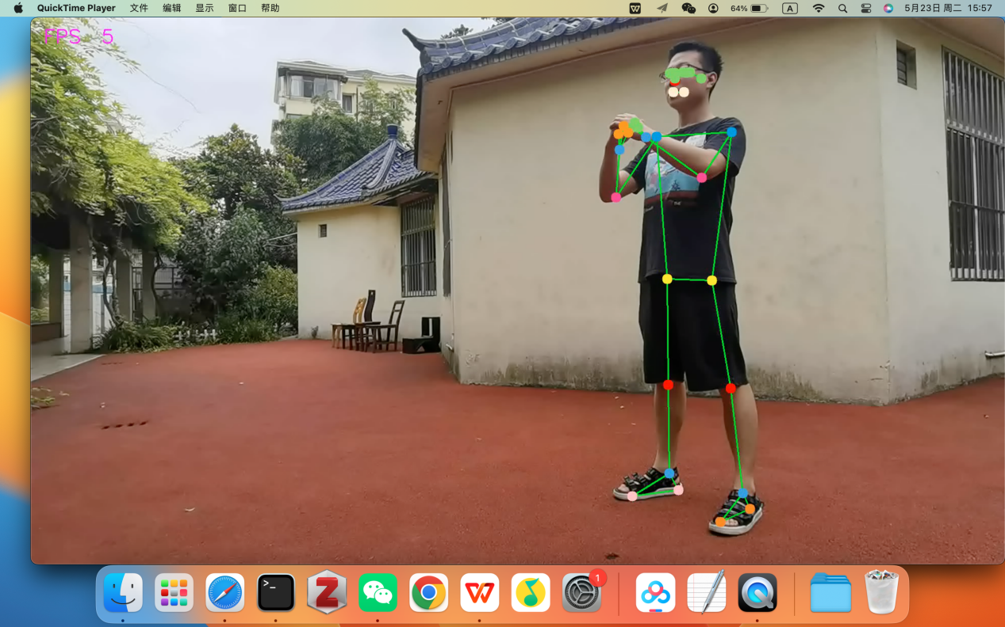

Test script：

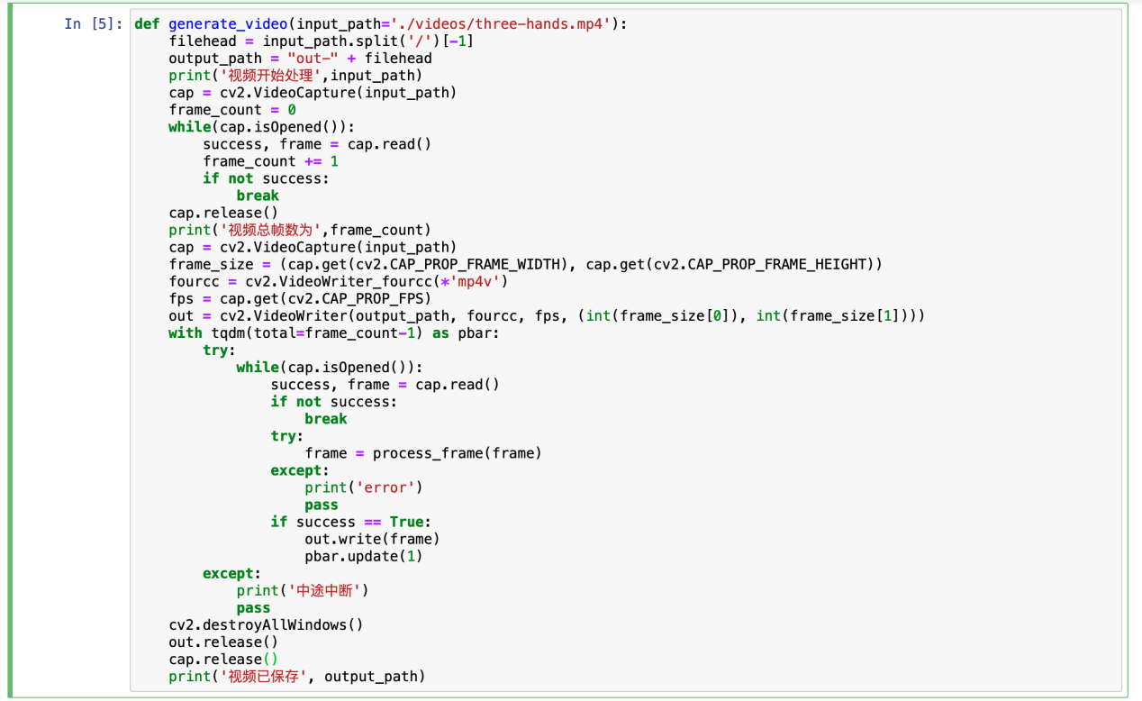

.

----------------------------------------------------------------------

Ran 1 test in 24.540s

OK

|  |
| --- |
| Test case 6:  Camera real-time test |
| Testing purposes:  Test whether the system can normally obtain device camera input and detect key points |
| Test Conditions:  The environment required for installation and testing: opencv-python, mediapipe, tqdm, time |
| Testing process:  Import toolkit, import model, input model, process single frame data, call camera to get each frame data |
| Desired result:  Successfully invoked the device camera, which can output images in real time and display key point information |
| Test result: passed, as shown in the figure |

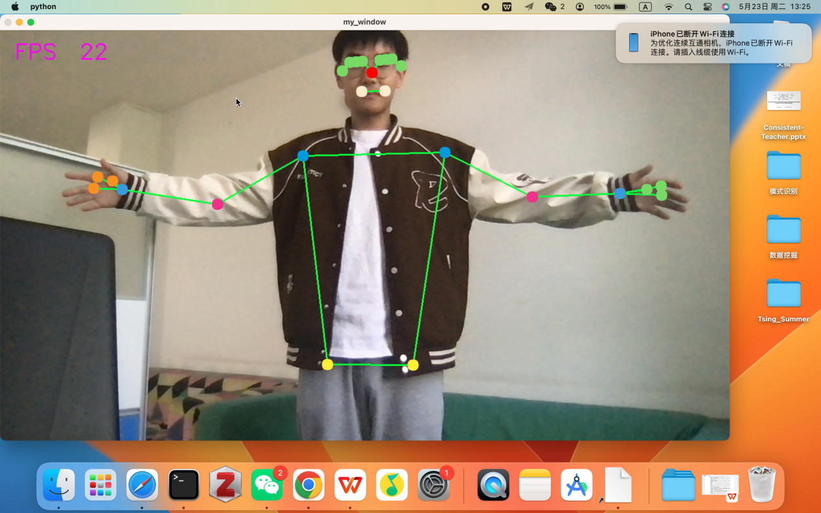

Test script：

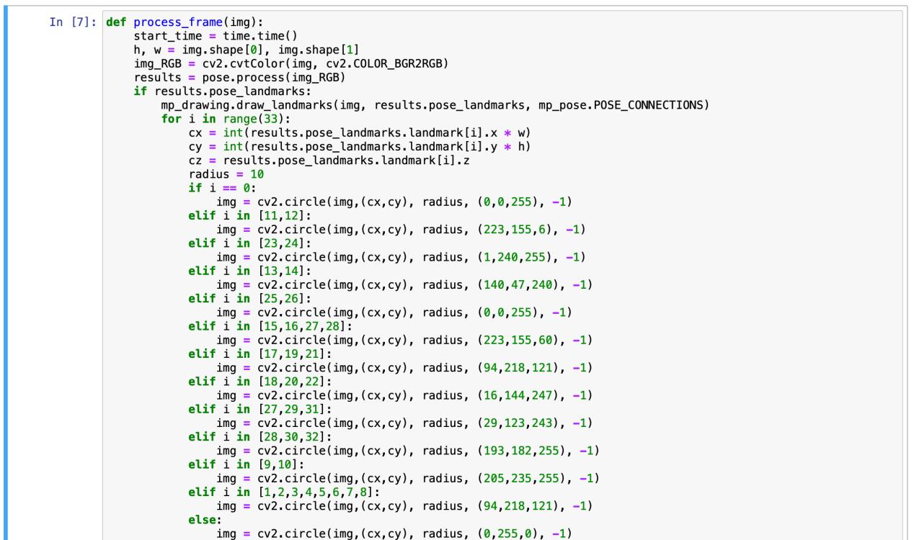

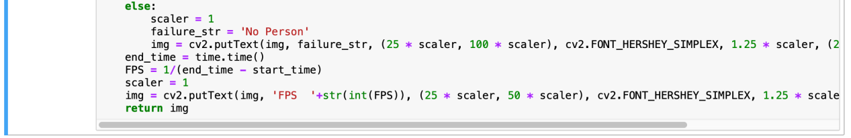

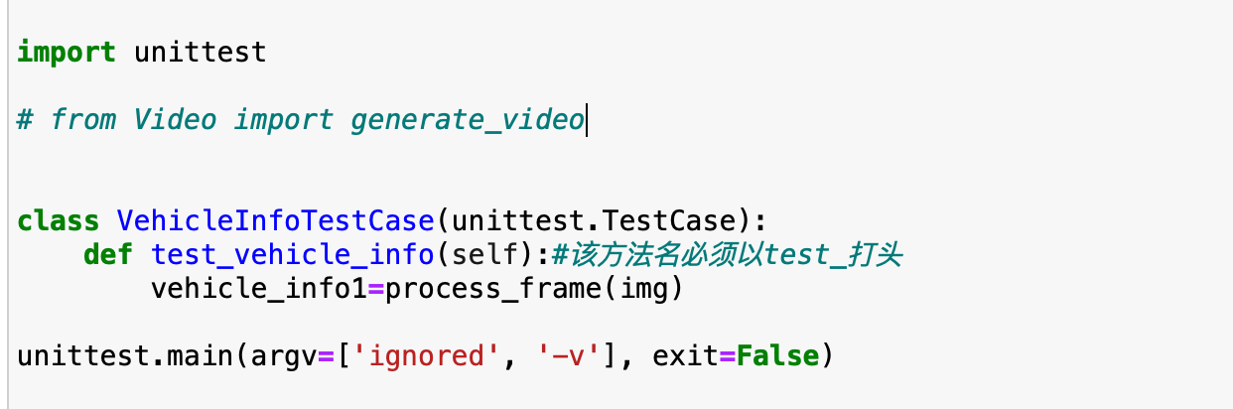

.

----------------------------------------------------------------------

Ran 1 test in 20.106s

OK

|  |
| --- |
| Test case 7:  Pose Classification Test |
| Testing purposes:  Whether the test system can normally classify and visualize human body poses |
| Test Conditions:  The environment required for installation and testing: opencv-python, mediapipe, tqdm, time, unittest |
| Testing process:  Build the test category and write the test code for the target function |
| Desired result:  Output OK |
| Test result: failed |

Test script:

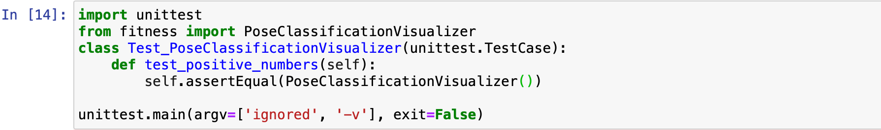

E

=================================================================

ERROR: /Users/spinulose/Library/Jupyter/runtime/kernel-e0eb3d93-32d1-46db-b345-4ca6bbb5a455 (unittest.loader._FailedTest)

----------------------------------------------------------------------

MessageError: Error: credential propagation was unsuccessful

----------------------------------------------------------------------

Ran 1 test in 6.901s

FAILED (errors=1)

## 10.Conclusion

During this project, we learned many valuable lessons. Here are some of the lessons we think are the most important:

* Always keep it purposeful and user-oriented

Before the project starts, we should have a clear understanding of the requirements and expectations, and ensure that the design and implementation of the software are both requirements-centric. At the same time, we should always keep the project goals clear and consistent, and avoid deviating from the original goals during the development process.

* Early testing and feedback gathering

In the project development process, we should conduct testing and feedback collection as early as possible to find and solve problems in time.

* Focus on code quality and maintainability

In the process of project development, we should pay attention to code quality and maintainability to ensure the reliability and stability of the software.

* Focus on teamwork and communication

Teamwork and communication are very important during project development. We should establish a good communication mechanism to exchange and coordinate various problems and needs in a timely manner. At the same time, we should also pay attention to teamwork and knowledge sharing to improve the overall level and efficiency of the team.